Prestan® Professional

AED Trainer PLUS

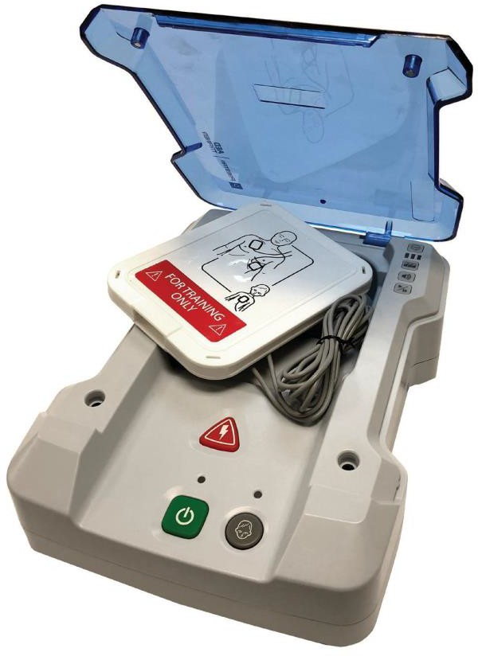

Model PP-AEDT2-101 —> Prestan Professional AED Trainer PLUS
(requires four (4) ‘C’ batteries; not included)
preprogrammed with English and a secondary language, one set of adult/child training pads with hard storage case, two
(2) sets of pad connector pins (one (1) set is a spare) and a carry bag.
Model PP-AEDT2-401 —> Prestan Professional AED Trainer PLUS 4-Pack (requires sixteen (16) ‘C’ batteries; not included) - Four (4) AED units preprogrammed with English and a secondary language, four (4) sets of adult/ child training pads with hard storage cases, eight (8) sets of pad connector pins (four (4) sets are spares) and a 4-pack carry bag.

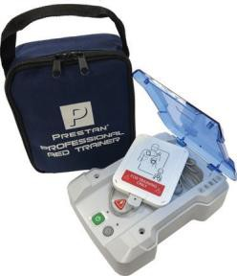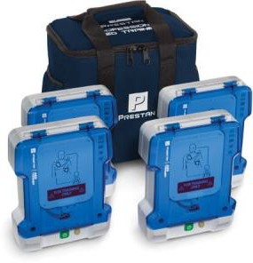

START HERE - GENERAL INFORMATION
- Use this instruction sheet as a reference for the Prestan Professional AED Trainer PLUS and Accessories. Please read through instructions before first use.
- Warning: The Prestan Professional AED Trainer PLUS is intended for training purposes only. It is NOT an Automated External Defibrillator (AED) and will not deliver a shock. To avoid confusion, it should NEVER be kept in the same area with AEDs.
- Owner’s information – For future reference, make note of the Prestan Authorized Distributor where you purchased your AED Trainer. Contact your Distributor for product questions, reordering parts/accessories, and/or warranty issues.
- For information on Prestan’s Authorized Distributors, help guides, resources and more, please visit the Prestan website at www.prestanproducts.com.

Purchase Information:

Distributor Name and Phone Number Purchase Date

FEATURES OF THE PRESTAN PROFESSIONAL AED TRAINER PLUS

- Adult / Child selection buttons
- Brightly illuminated shock button
  - Flashes when shock is advised
- On / Off button with lighted indicator and program pause option
- Sturdy, flip-up lid
  - Durable translucent lid & hinge
  - opening lid does not turn unit on
- Five training scenarios
- Clear & calm voice prompts
- Chest compression rate metronome
  - Metronome can be turned on or off
  - Metronome audible count reminders at ten (10), twenty (20) and thirty (30) compressions
- Automatic OR Semi-Automatic shock delivery
- Programming option to either include or not include time for breaths after compression cycle
- Remote Control Available (sold separately)
  - Controls multiple units
- Long Battery Life
  - Low battery voice prompt warning
  - Automatic shut-off for extended battery life
- Programming is compliant with current AHA Guidelines (2015)
  - Easy to replace language module if guidelines change

HIGH-PERFORMANCE TRAINING PADS

Start by installing your training pads onto the unit’s pre-installed cables. See page 6 for full instructions.
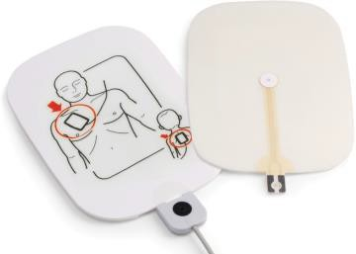
- Patented Pad Sensing System automatically advances the scenario programming when it detects the pads have been connected to any manikin
- Pads last approximately 100 uses (depending on care and use conditions)
- Long-life adhesive leaves no messy residue and adheres well to any CPR manikin
- Pads cable is pre-connected to the AED Trainer
- Dual graphics allow for adult and child training and shows anatomical placement
- Unique pad connector with locking connector pin
- Pads are stored in a convenient hard case for adhesive and sensor protection

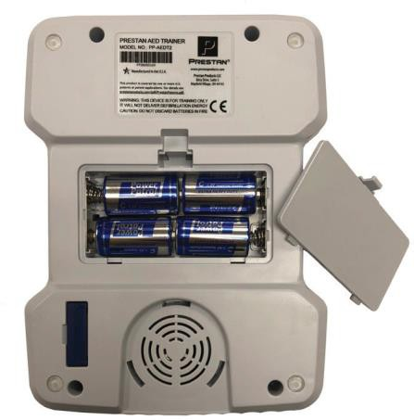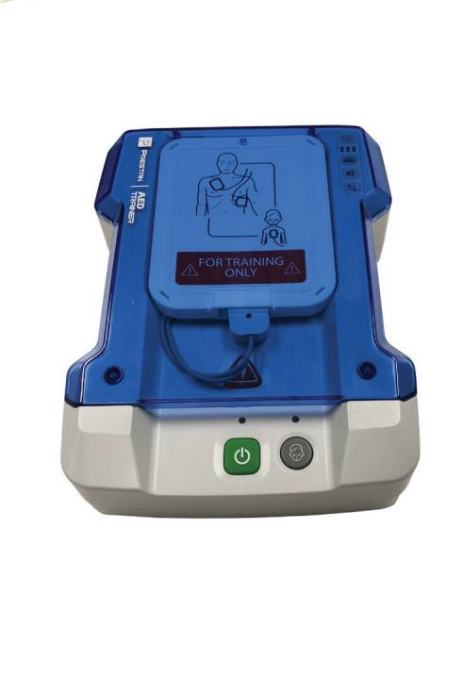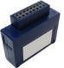AED TRAINER PLUS FEATURE GUIDE

FRONT OF UNIT

FLIP-TOP LID

CONTROL PANEL

TRAINING PADS STORAGE CASE

PAD CABLES
TRAINING PADS CONNECTOR

ON / OFF STATUS INDICATOR LIGHTS

ON / OFF / PAUSE BUTTON
SHOCK BUTTON

CHILD BUTTON

BACK OF UNIT

PRODUCT INFORMATION LABEL (MODEL / SERIAL NUMBER)

SPEAKER

LANGUAGE MODULE
BATTERY COMPARTMENT
(requires 4 ‘C’ batteries; not included)

NON-MARKING SILICONE PROTECTIVE FOOT (4)

ACTION BUTTONS

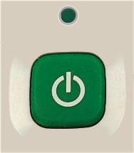ON / OFF BUTTON
- Push green button to start program / the indicator light above the button will turn on
- When unit is running, push and hold the button for three (3) seconds to shut off unit

CHILD BUTTON
- After power is turned on, the programming offers an audible option to select the Child Button
- Indicator light above the Child Button will light up when the Child option has been selected and is active
- Indicator light turns off if the program is paused, but turns back on when the program is resumed

SHOCK BUTTON
- Red Shock Button will flash when program instructs to deliver shock
- In Semi-Automatic mode, pushing the Shock Button while it is flashing will simulate delivering a shock and will stop the flashing and resume the program
- In Automatic mode, the Shock Button will flash approximately six (6) times before simulating auto- shock and resuming the program
On/Off Button

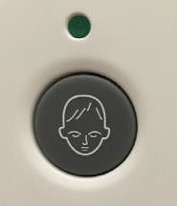
Child Button

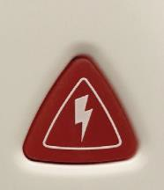
Shock Button

ASSEMBLY, SETUP AND USE
- Set aside the training pads (at top of box) and remove the cardboard tray from the shipping container
- Remove the PRESTAN PROFESSIONAL AED TRAINER PLUS from the box
- Unzip the PRESTAN PROFESSIONAL AED TRAINER PLUS carrying case and remove the plastic package containing the module and connector pins
- Remove the PRESTAN PROFESSIONAL AED TRAINER PLUS from the carrying case
- Insert the LANGUAGE MODULE into the back of the unit on the lower left-hand corner
- Pad Assembly
  - Open the plastic package and remove the Prestan Professional Training Pads
  - Find the ends of the AED Trainer cables that are not connected to the unit
  - Insert each pad into a cable connector (pad tab may need to be wiggled into place if fit is snug) and line up the hole in the tab of the pad with the hole in the connector. Ensure pads are not installed upside down (see step e. below)
  - 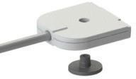Lock pads in place by pushing connector pins into holes, making sure the pin rests in the indentation in the cable connector

CABLE CONNECTOR CONNECTOR PIN
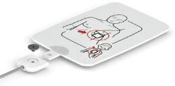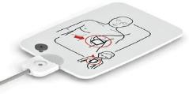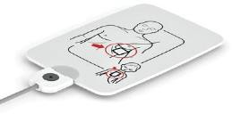
  - Ensure pads are not installed upside down (pad graphics should be on same side as the large head of the connector pin)
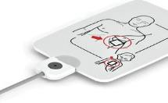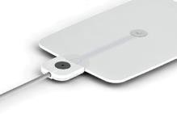

Upside Down

- continued on next page -

Assembly, Setup and Use - continued

  - Open the white plastic pad carrying case found in the unit
  - Turn pad over and remove the clear plastic liner from the AED Pad by gently pushing down on the tab end of the pad, causing the liner to separate
  - THROW THE CLEAR PLASTIC LINER AWAY (re-using the liner does not extend the life of the adhesive and may impact pad sensing ability)
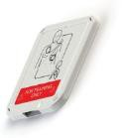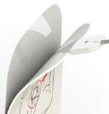

  - Adhere the pads to the INSIDE lids of the white plastic Pad Case, close the case
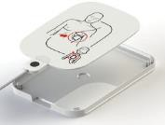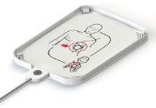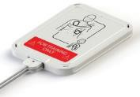
  - Coil the Cables, place them in the well and cover them with the Pad Case
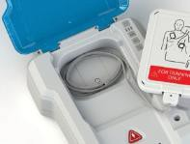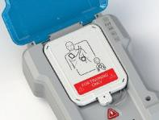

TRAINING PAD REPLACEMENT
- Prestan training pads will generally last approximately 100 uses (depending on use and care conditions)
- When needed, it is good practice to replace both pads at the same time
- 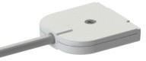Release the existing pads from the gray cable connectors by popping out the black pad connector pins from the small side with the tip of a ball point pen

CABLE CONNECTOR CONNECTOR PIN

- Slide the used pads out from the cable connectors
- Refer to Step #6 (Pad Assembly) on previous page to complete the installation

CONTROL PANEL

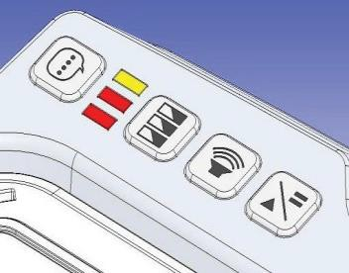LANGUAGE SELECTION BUTTON SELECTION INDICATOR LIGHTS SCENARIO SELECTION BUTTON VOLUME BUTTON
PAUSE/PLAY BUTTON

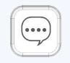The following information is a guide for customizing your AED Trainer. The unit may be customized while ON or OFF. The unit will beep to confirm and shut down (if ON) to reset when a language or scenario selection has been changed.

LANGUAGE SELECTION BUTTON
The LANGUAGE SELECTION BUTTON, located at the top of all the buttons on the Professional AED Trainer PLUS Unit, will toggle between the languages available.
- Press the button to toggle between the languages
- The last language selected will remain the default until the language button ispressed again to select another language

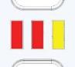SELECTION INDICATOR LIGHTS
The SELECTION INDICATOR LIGHTS are below the Language Selection button. The SELECTION INDICATOR LIGHTS are used during the setup of the unit. They indicate settings such as automatic or semi-automatic shock mode, ventilations modes, and metronome.
- Indicator lights are read left to right

- continued on next page -

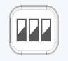Control Panel - continued

SCENARIO SELECTION BUTTON
The SCENARIO SELECTION BUTTON is located under the Indicator Lights.
  - The SCENARIO SELECTION BUTTON is used to select one of the five (5) scenarios available on the unit:
    - ▌A red indicator means ‘shock’
    - ▌A yellow indicator means ‘no shock’
  - ▌▌▌The factory default is for three (3) cycles, all of which are for ‘shock’
  - Continuously pressing the SCENARIO SELECTION BUTTON will cycle through the five (5) available scenarios:
    - Scenario 1 ▌▌▌ shock; no shock; no shock
    - Scenario 2 ▌▌▌ shock; no shock; shock
    - Scenario 3 ▌▌▌ shock; shock; no shock
    - Scenario 4 ▌▌▌ no shock; no shock; no shock
    - 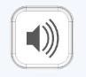Scenario 5 ▌▌▌ shock; shock; shock

VOLUME BUTTON
  - There are three (3) volume levels on the unit
  - By pressing the VOLUME BUTTON, you can increase or decrease the volume of the unit depending on need
  - The indicator lights will light up to indicate
    - ▌ Low Volume
    - ▌▌ Medium Volume
    - 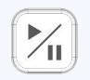▌▌▌ High Volume

PAUSE/PLAY BUTTON
  - When the PAUSE/PLAY BUTTON is pushed, the unit will pause the scenario
  - When in pause mode, three (3) yellow selection indicator lights ▌▌▌ will blink
  - Press the PAUSE/PLAY BUTTON again to resume the scenario

PROGRAMMING OPTIONS
Use combinations of buttons as directed below to program preferred settings for the unit.

AUTOMATIC / SEMI-AUTOMATIC
The Prestan Professional AED Trainer PLUS can be set to automatically deliver a simulated shock without depressing the Shock button.
- The Prestan Professional AED Trainer PLUS is preset from the factory in Semi- Automatic Mode – the simulated shock is delivered manually by pressing the red Shock Button when instructed and button is flashing
- To change this mode:
  - With the AED Trainer off, hold down the On/Off Button until two (2) beeps are heard (about 7-10 seconds) then release
» the first beep is for test mode so wait for the second beep
» the Shock Button will be flashing on and off
  - Look at the Selection Indicator Lights:
» Three (3) yellow lights – ▌▌▌ – mode will be Semi-Automatic
» Three (3) red lights – ▌▌▌– mode will be Automatic
  - To change the mode, push the Shock Button
- To exit and save, press the On/Off Button

VENTILATIONS ON / OFF
The Prestan Professional AED Trainer PLUS can allow time for administering breaths between compression rounds. This option can be toggled on or off.
- The AED Trainer is preset from the factory with ventilations ON
- To change this mode:
  - With the AED Trainer off, hold down the On/Off Button until two (2) beeps are heard (about 7-10 seconds) then release
» the first beep is for test mode so wait for the second beep
» the Shock Button will be flashing on and off
  - Look at the Selection Indicator Lights - there will be three (3) lit up in red or yellow depending on your Automatic/Semi-Automatic preference
  - 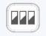Press the Scenario Selection Button below the lights until only the first two
(2) lights are lit
» Two (2) yellow lights – ▌▌ – the ventilations setting mode will be ON
» Two (2) red lights – ▌▌– the ventilations setting mode will be OFF
  - To change the mode, push the Shock Button
- To exit and save, press the On/Off Button

  - continued on next page -

Programming Options - continued

METRONOME ON / OFF
When doing compressions, the Prestan Professional AED Trainer PLUS will count by tens (10s) as a guide to the rate of 100 compressions per minute. Programming also offers an audible metronome tick (for each compression). This option can be toggled on or off.
- The AED Trainer is preset from the factory with metronome ON
- To change this mode:
  - With the AED Trainer off, hold down the On/Off Button until two (2) beeps are heard (about 7-10 seconds) then release
» the first beep is for test mode so wait for the second beep
» the Shock Button will be flashing on and off
  - Look at the Selection Indicator Lights - there will be three (3) lit up in red or yellow depending on your Automatic/Semi-Automatic preference
  - Press the Scenario Selection Button below the lights twice until only the first lights are lit
» One (1) yellow light – ▌ – the metronome setting mode will be ON
» One (1) red light – ▌– the metronome setting mode will be OFF
  - To change the mode, push the Shock Button
- To exit and save, press the On/Off Button

FEATURE SETTINGS

 | Ventilations On | Ventilations Off
CPR Metronome On | - Program begins with analyzing patient and advising shock or no shock based on user scenario setting.  - Audible prompt “BEGIN CPR” starts compression cycle.  - Metronome beats and audible prompt notes “TEN”, “TWENTY”, and “THIRTY” compression counts.  - After thirty (30) compression tones, the metronome pauses for an audible prompt to “GIVE 2 BREATHS”.  - Compression tones and breaths continue for five (5) cycles (two (2) minutes).  - Unit analyzes patient.  - Cycles repeat indefinitely following scenario shock pattern until unit is manually shut off. | - Program begins with analyzing patient and advising shock or no shock based on user scenario setting.  - Audible prompt “BEGIN CPR” starts compression cycle.  - Compression tones with audible  prompt to “CONTINUE CPR” every twenty-four (24) seconds (x4).  - Compression tones continue for two  (2) minutes.  - Unit analyzes patient.  - Cycles repeat indefinitely following scenario shock pattern until unit is manually shut off.
CPR Metronome Off | - Program begins with analyzing patient and advising shock or no shock based on user scenario setting.  - Audible prompt “BEGIN CPR” starts compression cycle.  - Audible prompt notes “TEN”, “TWENTY”, and “THIRTY”  compression counts.  - After time for thirty (30) compressions, the metronome pauses for an audible prompt to “GIVE 2 BREATHS”.  - Compression tones and breaths continue for five (5) cycles (two (2) minutes).  - Unit analyzes patient.  - Cycles repeat indefinitely following scenario shock pattern until unit is manually shut off. | - Program begins with analyzing patient and advising shock or no shock based on user scenario setting.  - Audible prompt “BEGIN CPR” starts compression cycle.  - Silence except for audible prompt to  “CONTINUE CPR” every twenty-four  (24) seconds (x4).  - Cycle stops at two (2) minutes.  - Unit analyzes patient.  - Cycles repeat indefinitely following scenario shock pattern until unit is manually shut off.

CARE AND CLEANING INSTRUCTIONS
- Store the Prestan Professional AED Trainer PLUS in its case and in a cool, dry area.
- Always return the training pads to the inside lids of the plastic storage case. This protects the adhesive and sensor. It also allows the sensor to reset the programming for next use.
- Starter batteries have been installed for immediate use of the unit. Starter batteries should be replaced with quality alkaline batteries within a month of purchase. If the unit will be stored for longer than a month, remove batteries to protect against corrosion.
- Never pick up or carry the unit by the cables.
- The Prestan Professional AED Trainer PLUS should be kept clean. If it becomes soiled, simply wipe with a clean, slightly damp, soft cloth. If the Trainer is extremely dirty, common cleaners can be used cautiously. DO NOT USE ABRASIVE MATERIALS OR CLEANING PRODUCTS ON THE UNIT. DO NOT SUBMERGE THE UNIT IN WATER.

WARRANTY
Three (3) Year Limited Warranty
Prestan provides a three (3) year limited warranty for its core product line. Warranty does not cover consumable items. For full warranty details that are applicable to this product, visit the Resources section of www.prestanproducts.com.

TROUBLESHOOTING / TEST MODE
Is the unit programming not progressing past “place pads on patient”? Enter TEST MODE to determine if your pads or cables need to be replaced. Make sure the training pads are stored in the pad storage case before starting the test.
- With the AED Trainer off, hold down the On/Off Button until one (1) beep is heard (about 4-6 seconds) then release
  - if you reach two (2) beeps, that is programming mode - turn unit OFF and start again
  - the Shock Button will be flashing on and off
- Remove a training pad from the case and lightly squeeze the sensor (round disk in center of adhesive)
- If a beep is heard - that pad and cable is in good working condition
- Repeat Steps 2 and 3 above with the other training pad
- If a beep is not heard - replace the pad with a known working pad (see Training Pad Replacement section on page 7) and try again
  - If a beep is now heard - the original pad needed replacing
  - If a beep is still not heard - new cables are needed
- Press On/Off Button to quit Test Mode

TROUBLESHOOTING GUIDE

SYMPTOM | POSSIBLE ISSUES OR COMMENTS | SOLUTIONS
Unit does not turn on | - Unit must be manually turned ON  - Batteries are not properly installed  - Batteries are missing, batteries are dead or battery contacts may be corroded  - Language Module is not installed | - Push green power button  - Re-orient batteries properly  - Replace batteries and check condition of battery contacts  - Insert language module into backside of unit
Both pads attached to manikin but device will not advance to analysis  Note: Entering TEST MODE may provide the answer (see previous page for instructions) | - Operational solution  - Pad is inserted backwards in the cable connector  - Pad or adhesive worn out or adhesive is dirty | - Insure pads are pressed on firmly so that the sensor in the center of the adhesive is flatly touching a surface (press down on pad center)  - Push out black connector pin, flip pad around and re-secure with black connector pin (see Training Pad Replacement instructions on Page 7)  - Replace pad (pads last approximately 100 uses with proper care)
Device proceeds to analyzing before both pads have been placed on the manikin | - Pads not properly positioned in pad case prior to starting program | - Re-position pads in case to lay completely flat and sensor is positioned in recessed area of pad case
Device delivers shock before shock button is pressed | - Device is In Automatic mode | - Change back to Semi- Automatic Mode (see instructions on Page 10)
Device prompts  “Replace Batteries” | - Device will run ten (10) or more hours with low batteries | - Replace batteries within ten  (10) hours
Device suddenly shuts down or voice prompts are distorted | - Batteries are very low, almost dead | - Install new batteries
Pad pulls out from pad connector | - Black pad connector pin may be missing | - Install new black connector pin
Pad will not stick to the manikin | - Adhesive is worn out or may have become dirty | - Replace pads (pads last approximately 100 uses with proper care)

Contact your Prestan Authorized Distributor for Warranty Assistance

PARTS & ACCESSORIES
Contact your Prestan Authorized Distributor for Pricing and Ordering

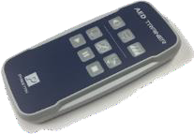

PP-AEDT2-100-R
Remote Control for the Professional AED Trainer PLUS Comes with two (2) ‘AA’ batteries installed. Optional Remote allows control of multiple units at a time.
Features “pads on/off” and “push harder” prompts.

11401
Single Carry Bag for the Professional AED Trainer PLUS

11402
4-Pack Carry Bag for the Professional AED Trainer PLUS

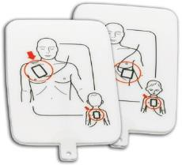

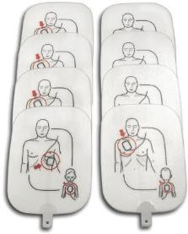
PP-APAD2-1
Single set of Adult/Child Training Pads for the Professional AED Trainer PLUS
PP-APAD2-4
Four (4) sets of Adult/Child Training Pads for the Professional AED Trainer PLUS

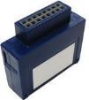

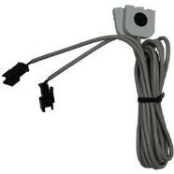
RPP-AEDT2-CABLE
Set of Replacement Cables for the Professional AED Trainer PLUS

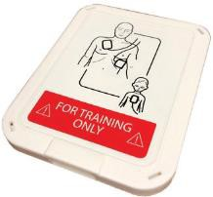
PP-ACASE2-1
Replacement Pad Storage Case for the Professional AED Trainer PLUS
PP-AEDT2-101-M English/Spanish PP-AEDT2-102-M English/French Language Module for the Professional AED Trainer PLUS.
Additional languages available based on distributor-represented geographic area.

www.prestanproducts.com

